
Year Group | Years 1 and 2 / P2-3
Unit Name | The Great Veg Vote
Duration | 20-minute lesson
Useful Resources | All resources available online here:  https://eatthemtodefeatthem.com/schools/digital-resources/  Including  - The Veg Hunters Assembly  - Great Veg Vote PowerPoint showing the different veg  - Great Veg Vote voting forms  - Great Veg Vote results charts
Link with National Curriculum: | KS1 Science:  Animals as Humans describe the importance for humans of exercise, eating the right amounts of different types of food, and hygiene.  RSHE: Health education in primary school starts with the benefits and importance of physical activity, good nutrition and sufficient sleep, and supports pupils to develop emotional awareness.
Key Learning Objectives | - To name a variety of vegetables  - To take part in a simple vote  - Collect and talk about results  - Understand that everyone can have a different choice
Key Vocabulary | Healthy  Vegetables  Rainbow  Strong  Energy  Grow  Nutrients | Vitamins  Minerals  Bones  Calcium  Teeth  Skin  Hair
Lesson Activity | Introduce the Great Veg Vote. Veg Power and the Eat them to Defeat Them team want to know your schools’ favourite vegetable and find out from children across the country what is the nation’s favourite vegetable, and they need this school/class to tell them which vegetables they like and eat regularly.  Teacher to introduce/show children the five choices of vegetable, see Great Veg Vote PowerPoint for visuals:  - Carrot  - Peas  - Sweetcorn  - Broccoli  - Pepper  Ask:  - Do you recognise these vegetables? Have you tried them before?  - Talk about which is the most colourful, which can you eat raw? Which are the crunchiest? Which are the sweetest tasting? Which are the biggest?  - If you have fresh vegetables this is a great opportunity to pass the vegetables round, unpack the sweetcorn if you have a whole one available and let them feel them and describe them - smooth, bumpy, shiny, tiny, round, etc.  Explain  “We are going to have a vote to choose our class’s favourite vegetable!”  Explain how the class are going to vote – you can vote for every vegetable that you like to eat so you can vote for all 5 of the vegetables if you definitely like all 5 of them.  Note to teacher - you could get them to vote for their favourite if that is simpler for the class, but we would also be interested in which vegetables they like and if there is a least popular vegetable too. This can be followed by themes at lunchtime or other activities to encourage the school or individual children to try and they may not have tried or do not currently like. This is an important step to support children to increase the variety of vegetables they will eat.  Choose the way that will work best for your class - hands up for each vegetable or hands up if you don’t like one of the vegetables, cubes in jar, going to different areas of the classroom or you can use these voting forms available on our website (see web details above).  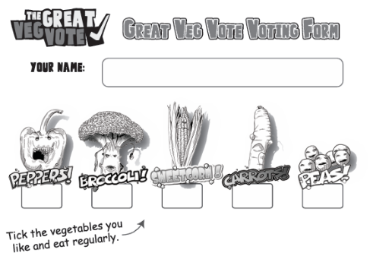  Explain that it is ok to have different opinions and that no one’s choice is wrong/right.  Count the votes together:  - Count aloud, Match numbers to amounts, Compare totals  - Has everyone voted – and everyone happy with their choices  Ask:  - Which vegetable has the most votes?  - Which has the least?  - Do any of the vegetables have the same number of votes?  - Which colour is the least popular.  You can enter your results on this form on this scorecard or ask the class to fill in this wallchart – we are sending you a massive A1 colour version of this wallchart to show the whole school results (that will arrive shortly before half term)  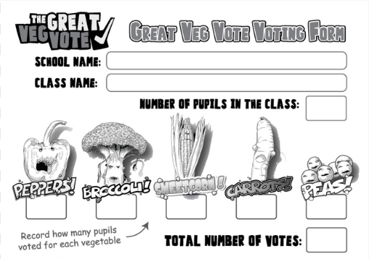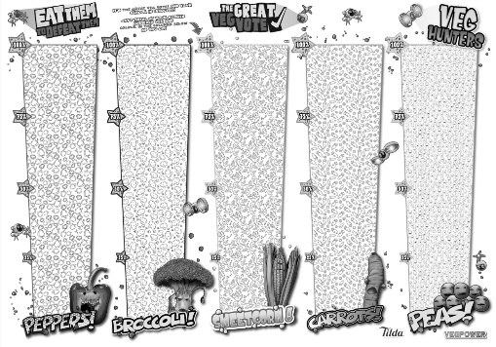  PLENARY –Reveal the winner  Discussion with pupils:  - Why do you think this is the most popular? Taste? Easy to eat?  - Is it okay if people choose different ones? (Yes!)  - Are you surprised by which vegetable got the most votes?  - What colour is your vegetable?  - How does this vegetable help us? (Link to Eat a Rainbow)  - Which vegetables are each of the pupils ready to try which they don’t currently like?
Additional activities | - Can they do the Great Veg Vote at home with their family?  - Can you suggest different vegetables that should have been in the Great Veg Vote.
Assessment | Assess progress during the lesson through observation and assessment during lesson.

Veg Power is a not-for-profit organization dedicated to getting children to eat more fruit, vegetables and beans. You can find many more lesson plans, teaching resources and ideas on our website. Thanks for your support.
Vegpower.org.uk/schools

