Year Group | Years 3- 6
Unit Name | The Great Veg Vote
Duration | 45- 60 minutes (or quick 10 minutes vote only)
Useful Resources | All resources available online here:  https://eatthemtodefeatthem.com/schools/digital-resources/  Including  - The Veg Hunters Assembly  - Great Veg Vote PowerPoint showing the different veg  - Great Veg Vote voting forms  - Great Veg Vote results charts
Link with National Curriculum: | KS2 SCIENCE  Animals as Humans  Y3: identify that animals, including humans, need the right types and amount of nutrition, and that they cannot make their own food; they get nutrition from what they eat  Y6: recognise the impact of diet, exercise, drugs and lifestyle on the way their body’s function  RSHE: Health education in primary school starts with the benefits and importance of physical activity, good nutrition and sufficient sleep, and supports pupils to develop emotional awareness.  ENGLISH: To plan, write and deliver a persuasive argument to a chosen audience
Key Learning Objectives | - To take part in a democratic vote  - To plan and deliver a persuasive speech, using scientific facts to support opinions  - Understand the importance of fair debate and listen to and respond to different viewpoints
Key Vocabulary | Healthy  Vegetables  Rainbow  Strong  Energy  Grow  Nutrients | Vitamins  Minerals  Bones  Vote  Democracy  Persuasion  Facts  Audience
Lesson Activity | Introduce the Great Veg Vote. Veg Power and the Eat them to Defeat Them team want to know your schools’ favourite vegetable and find out from children across the country what is the nation’s favourite vegetable, and they need this school/class to tell them which vegetables they like and eat regularly.  Which vegetable should be our class champion – and how can we persuade others fairly?  Meet the candidates:  Teacher to introduce/show children the five choices of vegetable, see Great Veg Vote PowerPoint for visuals:  - Carrot  - Peas  - Sweetcorn  - Broccoli  - Pepper  Teacher to explain that each vegetable wants to win the Great Veg Vote. Your job is to help one vegetable win — using facts, and persuasion- not shouting!  Explain how the process is going to work:  (choose the approach which will work best with your class)  - Simple show of hands you can vote for each vegetable that you like to eat so you can vote for all 5 of the vegetables if you definitely like all 5 of them. (10 mins max)  - Children to work in teams to prepare campaign for one each of the vegetables and prepare a short speech – E.g. 3 reasons why their vegetable should get more votes, a fact and a persuasive slogan or reason  - Children to work individually to campaign for their favourite vegetable following speech guidelines from above 3 reasons why their vegetable should win, a fact and a persuasive slogan or reason  IDEAS TO EXTEND LEARNING AND EXPERIENCE OF ELECTION CAMPAIGNS  HUSTINGS and DEBATES.  - Teacher to explain what Hustings are and Teacher to run, model and guide hustings ensuring it remains democratic and respectful  - Teacher to run, model and guide debates: Q: Why is great about your vegetable? Ensuring it remains on the positive of different veg rather than the negative of other veg, keep it democratic and with only respectful disagreements  VOTING PROCESS  Explain how the class are going to vote – Everyone gets up to five votes. Pupils can vote for all the vegetables that they like so that could be one vote for all 5 vegetables if you like all 5 vegetables and all votes count.  Choose the way that will work best for your class - hands up, secret ballot, voting tokens or you can use these voting forms available on our website (see web details above).  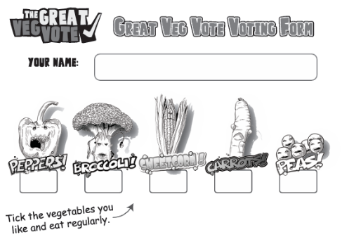  Explain that it is ok to have different opinions and that no one’s choice is wrong/right.  Count the votes together:  - Count aloud, Match numbers to amounts, Compare totals  - Has everyone voted  Ask:  - Which vegetable has the most votes?  - Which has the least?  - Are any the same?  Democracy means listening, thinking, and accepting the result — even if it is not your choice.  You can enter your results on this form on this scorecard or ask the class to fill in this wallchart – we are sending you a massive A1 colour version of this wallchart to show the whole school results (that will arrive shortly before half term)  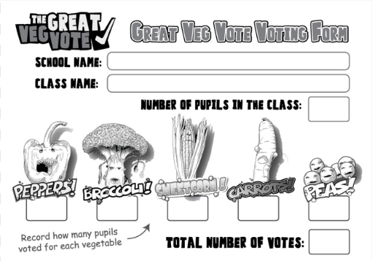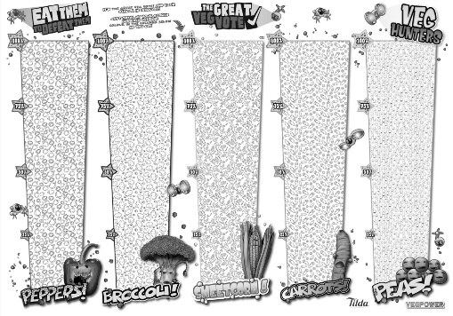  PLENARY – Discussion with pupils:  Reveal the winner  - Why did the vegetable win? Did the speeches/hustings have any influence and change people’s minds?  - Why do you think this is the most popular? Taste? Easy to eat?
Additional activities | - Can they do the Great Veg Vote at home with their family or get all the parents involved too to do a whole school vote?  - Can you suggest different vegetables that should have been in the Great Veg Vote.  - How can we persuade people to eat the least popular vegetable?
Assessment | Assess progress during the lesson through observation and assessment during the lesson.

Veg Power is a not-for-profit organization dedicated to getting children to eat more fruit, vegetables and beans. You can find many more lesson plans, teaching resources and ideas on our website. Thanks for your support.
Vegpower.org.uk/schools

