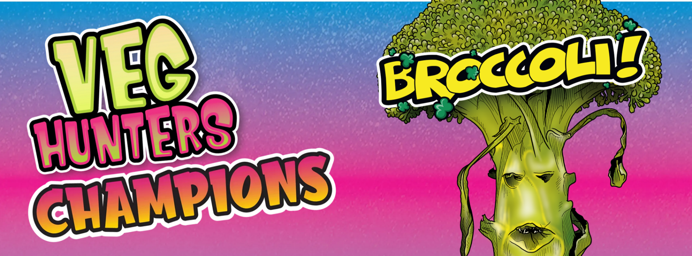
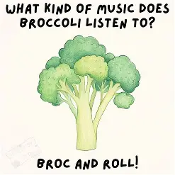
How to Boost the Broccoli and make your school want to give it a try:
Come up with a fun name or slogan “Be a Broccoli Booster
Find some broccoli jokes or write your own!
Amaze them with these fun facts or find out some of your own….
- Ancient Romans loved broccoli — it’s been eaten for over 2,000 years.
- Broccoli was once considered an exotic vegetable in Europe.
- Broccoli contains more vitamin C than an orange (per serving).
- Broccoli florets aren’t just cute mini-trees – they’re packed with vitamins
- Broccoli is basically tiny flower buds — if you wait too long, it blooms yellow flowers.
- It’s related to cauliflower, cabbage, and kale (they’re all plant cousins).
- Broccoli can take anywhere from 70 to 140 days to be ready to pick and eat after planting.
- Broccoli is high in calcium, which helps to support strong bones.
- Broccoli can be eaten raw or cooked

