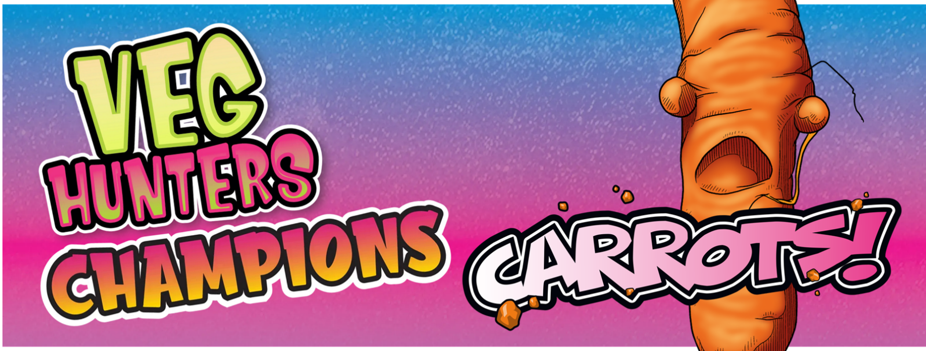
How to Champion the Carrot and make your school want to give them a try:
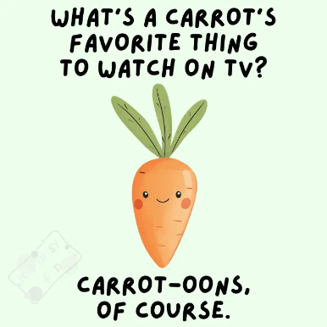
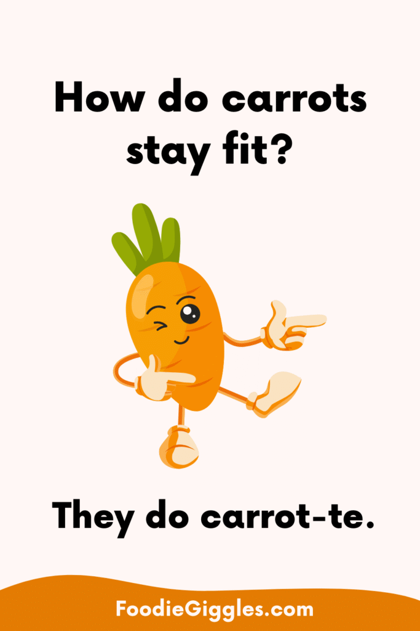
Come up with a fun name or slogan – “It’s crunch time carrots”
Find some carrot jokes or write your own!
Amaze them with these fun facts
🥕 1. Carrots come in many colours!
Not just orange — carrots can also be purple, red, yellow, and white. A rainbow of veggies!
🐰 2. Rabbits love carrots (but only a little!)
Rabbits do eat carrots, but they should only have them as a treat because carrots are quite sweet.
👀 3. Carrots help your eyes!
Carrots have vitamin A, which is good for your eyesight
🎨 4. Carrots weren’t always orange!
Long ago, carrots were mostly purple and white. The orange ones were made popular in the Netherlands.
🏆 5. World record carrot!
The longest carrot ever was over 6 metres long — that’s taller than a giraffe
🌱 6. Carrots grow underground!
The part we eat is the root, which grows under the soil. The green tops grow above ground. The longer a carrot grows, the sweeter it becomes.

